**HTML BASIC, TEXT AND FORMATTING TAGS**

All elements of HTML documents are annotated with ‘tags’. Tags are usually a literal abbreviation of the intended formatting the tag is used for. For example, **<body>** tags are used to mark the start of the body or visible portion of web pages. Every opening tag has a closing tag (except the img tag) that is the same as the opening tag but with a leading backward slash (/).

**<html>**: Opening tag

**</html>**: Closing tag.

**Basic Tags**

1. **<html></html>** Creates an HTML document. All elements (codes) are enclosed within these tags.
2. **<head></head>**Sets off the title and other information that isn’t displayed on the web page itself.
3. **<title></title>** Come within the head tags and is used for keywords search and page indexing in search engines. Anything Within the head tags is not visible on the web page.
4. **<body></body>**Sets off the visible portion of the document. All Visible Elements of the Html page is enclosed within these tags.

***Body Attributes***

* 1. <body bgcolor=""> Sets the background color of webpage.
  2. <body text=""> Sets the text color, using name or hex value
  3. <body link=""> Sets the color of links, using name or hex value
  4. <body vlink=""> Sets the color of followed links, using name or hex value
  5. <body alink=""> Sets the color of links on click using name or hex value
  6. <body ondragstart="return false" onselectstart="return false"> Disallows text selection with the mouse and keyboard. *If you do not want anything from your web page to be copied.*

**MINI TASK 1:**

1. **Get the ‘hex’ values for red, blue, green, white and black.**
2. **Go to** [**http://www.yourhtmlsource.com/myfirstsite/**](http://www.yourhtmlsource.com/myfirstsite/)
3. **Open and View the source page**
4. **Try locating the Opening and Closing;**
   1. **html tags**
   2. **body tags**
   3. **head tags**
   4. **title tags**
5. **Open the following files:**

**>> Root/Users/Desktop/GIT/CFGBrunel-Beginner-Course/MyWebsite.**

* **In your desktop, create a file ‘GIT’ that will hold all your github repositories and linked to github.**
* **Within GIT create a file called CFGBrunel-Beginner-Course. This is a repository for this course that will be uploaded to github (during the git lecture).**
* **Within CFGBrunel-Beginner-Course create another file called MyWebsite for all files to be uploaded to our web site.**

THE BASIC STRUCTURE OF AN HTML DOCUMENT

**<html>**

**<head>** <!—header for HTML Document: Not visible on web page🡪

**<title>** KEYWORDS FOR GOOGLE SEARCHES **</title>**

**</head>**

**<body>**

Every other thing comes in here.

**</body>**

**</html>**

**Header Tags**

1. **<hl></hl>** (Heading 1) Creates the largest headline.
2. **<h2></h2>**(Heading 2) Creates the next largest headline.
3. **<h3></h3>** (Heading 3) Creates the next next largest headline.
4. **<h4></h4>** (Heading 4) Creates a small headline.
5. **<h5></h5>** (Heading 5) Creates a smaller headline.
6. **<h6></h6>**(Heading 6) Creates the smallest headline.
7. **<header></header>** Used to specifies Headings for visible portions of web pages. I.E Heading of body or main page.

**Text & Formatting Tags**

1. **<pre></pre>**Creates preformatted text.
2. **<code>** tag is a phrase tag. It defines a piece of computer code.
3. **<b></b>** (Bold)Creates bold text
4. **<strong></strong>**Creates bold text
5. **<i></i>** (italics) Creates italic text
6. **<em></em>**(Emphasis) Creates italic text
7. **<u></u>** (Underline) Used to Underline Text
8. **<font size="3"></font>** Sets size of font, from 1 to 7
9. **<font color=""></font>**Sets font color, using name or hex value
10. **<p></p>** (Paragraph) Creates a new paragraph. All Text information or sentences com within these tags.

**Add Attributes**

* 1. **<p align="left">**Aligns a paragraph to the left (default), right, or center.

1. **<br>**(Break) Inserts a line break

**MINI TASK 2:**

1. **Open Sublime Text Editor.**
2. **Change the ‘Tab Size’ and Language to ‘4’ and ‘HTML’ respectively at the bottom right corner of the User Interface.**
3. **Attempt creating the HTML code that produces this section of the web page in figure 1 below.**
   1. **Start by creating tags for the basic structure of HTML Documents.**
   2. **Think of useful combination of keywords from HTML, Web Design, Women, Engineering, Code First Girls, London, CSS, JQuery etc that optimizes searches for ‘Web Design Courses for Girls, London, Brunel, Uxbridge’. Add this to the <title> tag.**
   3. **Within the <body> tags;**
      1. **Create the main page heading as seen below with <h1> tags.**

**<h1> PAGE HEADING </h1>**

* + 1. **Use a <p> tag for texts, sentences and paragraphs.**

**<p> Paragraph Text </p>**

* + 1. **open and close four sub headings (Tags, Closing Tags, Attributes and Elements) with <h2> sized tags.**

**<h2> SUB HEADING 1 </h2>**

**<p> Paragraph </p>**

**<h2> SUB HEADING 2 </h2>**

**<p> Paragraph </p>**

**<h2> SUB HEADING 3 </h2>**

**<p> Paragraph </p>**

**<h2> SUB HEADING 4 </h2>**

**<p> Paragraph </p>**

1. **Hint: Do not forget to make bold texts bold using the appropriate tags.**
2. **Hint: Add an attribute to the body tag that changes the background color to anything BUT WHITE.**
3. **Save this file as index.html in Desktop/GIT/CFGBrunel-Beginner-Course/MyWebsite.**

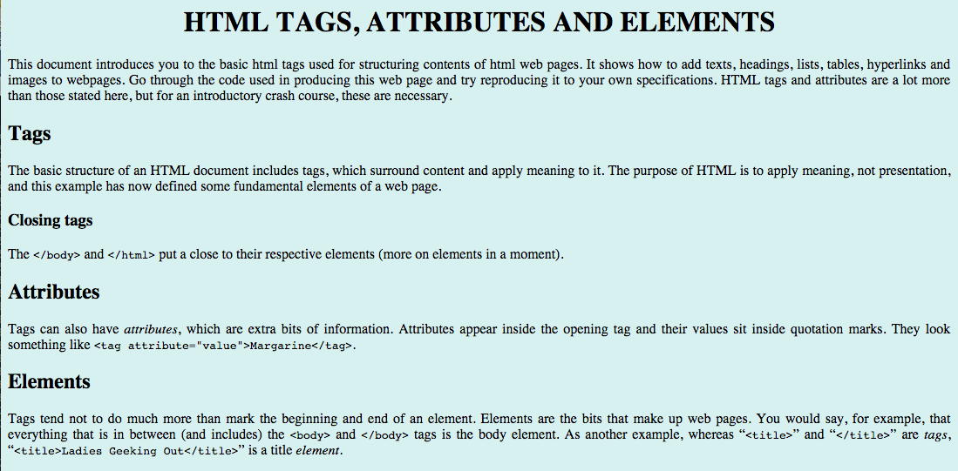

Figure 1: